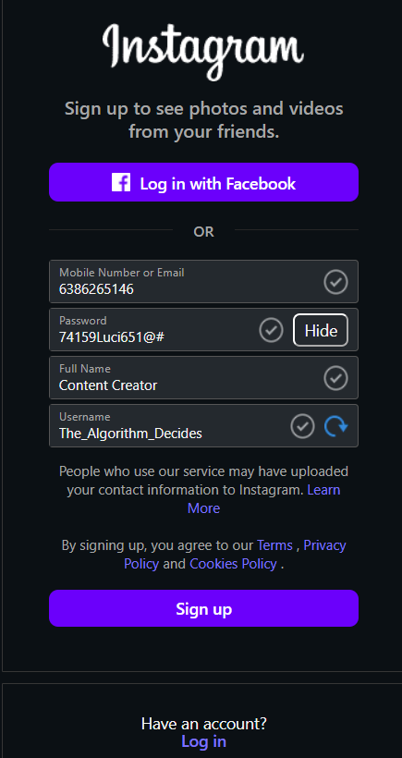

Seceret ID
dVNQNEhrWU5RVnVjOGY2ZzB4NFc6MTpjaQ
Secert
HiPnSMu-YWz3HhS2ExlPBgac4QI86EhTVmEgzikwJvWmiBntq1

Consumer Key
Copy
oPR3mVIpEBYfGRsS5U8zyJ8CH
Consumer Key Secret
Copy
3Kf057Nubjq2yMEAUwhFECEtk6rncEOJcN0A4L7WDgZDjlArCU

Access Token
Copy
2019712621243662337-yIr2SgiwxfZfZ9ETkxL9GilMlGpTyJ
Access Token Secret
Copy
ssMXRFJzXG2W08uhY58O614OETq73WqbBX4hHb8NQzrA0

